MSE3381 Project Report

Group 12

Azhar Rasiwala, Devon Bradley, J.D. Herlehy

Dec. 8, 2021

**Table of Contents**

**Introduction** **2**

**Design Description** **3**

**Engineering Analysis** **5**

**Computational Results** **6**

**Solidwork Simulation Results** **7**

**Graphical Results** **9**

**Figure 11: Graphical Results for Acceleration, Includes Calculation for Acceleration Polygon** **11**

**Discussion** **12**

**Conclusions** **14**

**Appendix** **15**

# Introduction

This report aims to design a punch via crank rocker mechanism. Constraints for the mechanism solution are as follows:

* Stock thickness must be between 10 and 25 mm
* The punch-press is to make circular holes between 40 and 100mm diameter
* Punch stroke Smax - Smin is 15 to 25 times the stock thickness (*h*)
* For negligible slider eccentricity, crank length must be half the punch stroke: r2 = 0.5(Smax - Smin)
* Connecting-rod length r3 must be 2.5 to 4 times larger than punch stroke
* After penetrating the stock, the punch must continue to travel at least 3 times more than stock thickness
* Slider eccentricity r1 is between 0.5 and 1.25 times that of the stock thickness (*h*)
* The number of punches performed equals the average crank rpm (ωp), and should be between 80 and 120 holes per minute
* The mechanism has to have a mobility 1

There is also the design goal of having the greatest magnitude of force at the end of the punch when the end of the punch is contacting the top of the stock.

Throughout the report, there are two key assumptions that were made:

* The material to be punched has an ideal plastic behavior
* The friction in the joints of the crank-slider mechanism, and between the punch and the

stock is negligible

Also note that all distance measurements are in millimeters unless otherwise stated, Our chosen motor speed is 100 RPM, and that positive angles are in the clockwise direction with 0° being the positive x axis.

# 

# 

# Design Description

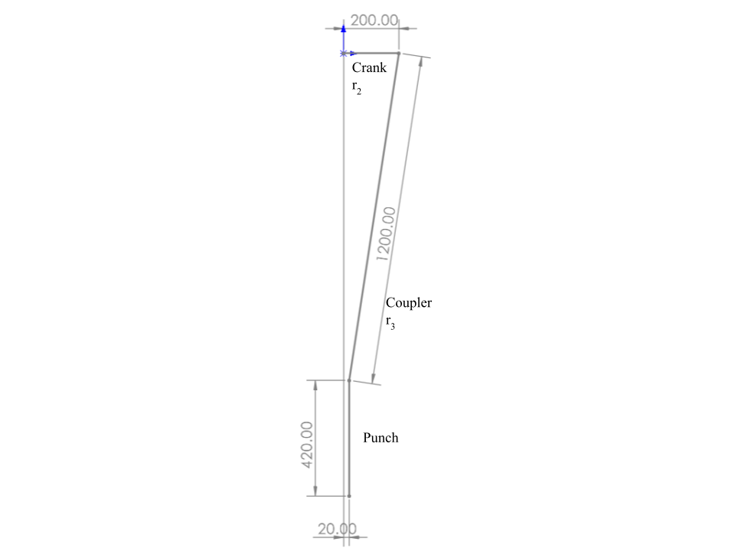

**Figure 1:** Punch Press Schematic

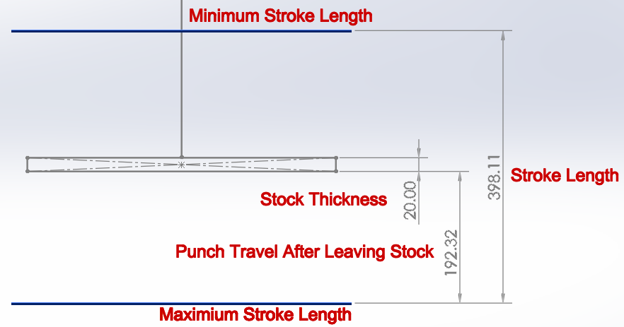

**Figure 2:** Stroke Length Verification

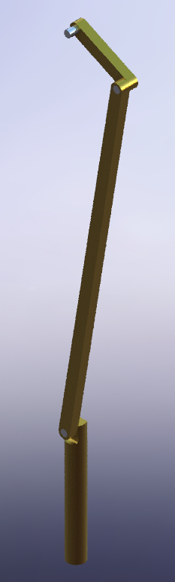

**Figure 3:** 3D Implementation

# 

# 

# Engineering Analysis

To ensure our design solution was met, there is a constraint for the mechanism to have a mobility of 1. This was confirmed with mobility equations in a sketch:

**Figure 4:** Mobility Calculations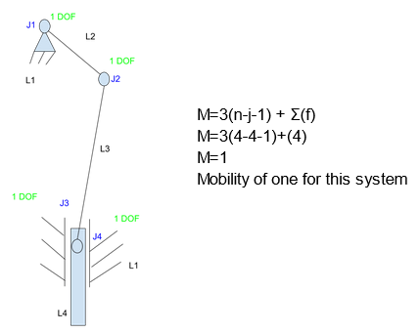

To meet the constraints of the design, values were within the range specified and were divisible by 5 to help simplify the calculations. The placement of the stock relative to the motor in the vertical direction was chosen to meet our goal of having the highest force output when the bottom of the punch first touches the top of the stock. This was done by setting θ2 to be 0° and then positioning the stock such that its top touched the bottom of the punch. The measurement was taken to be 1.42 meters down from the shaft of the motor.

# 

# Computational Results

**Figure 5:** Computational Analysis Results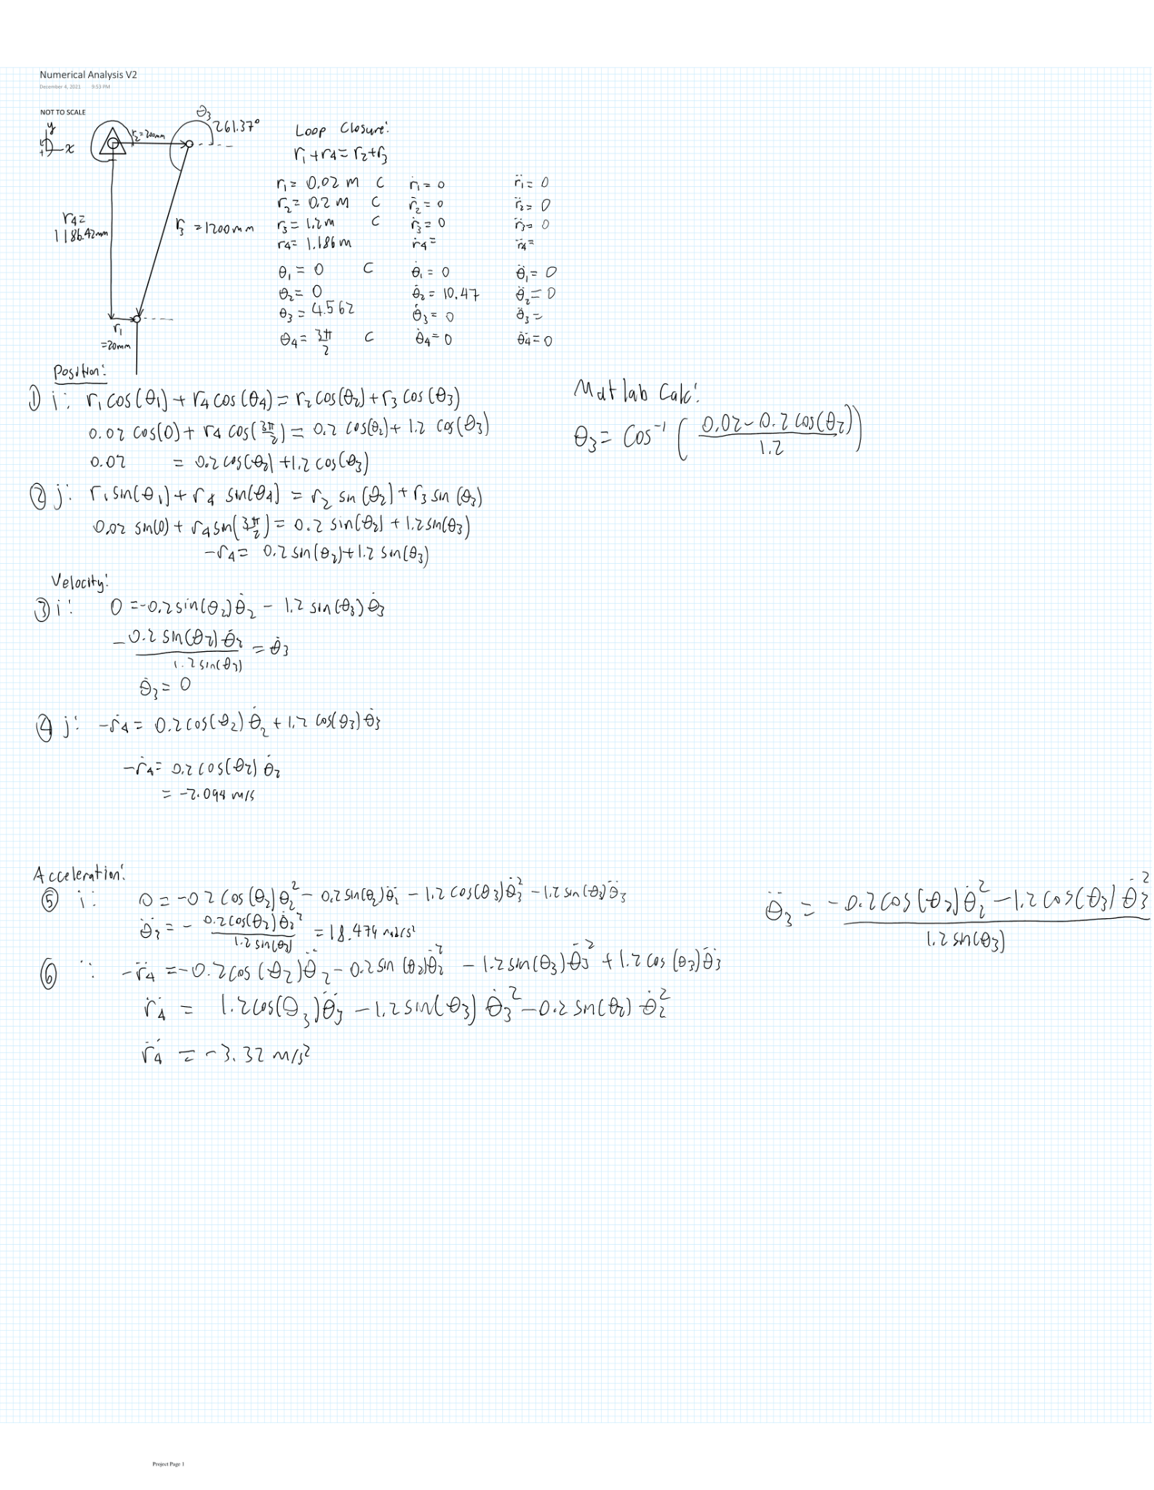

# Solidwork Simulation Results

To plot with respect to the angle instead of time, the function was used to convert the time to an angle in degrees (see Appendix). S_SW is the end of the punch in the Solidworks simulations and S_Comp is the end of the punch from the computational formulas implemented with Matlab.

**Figure 6:** Displacement Results Comparing Computational and Simulation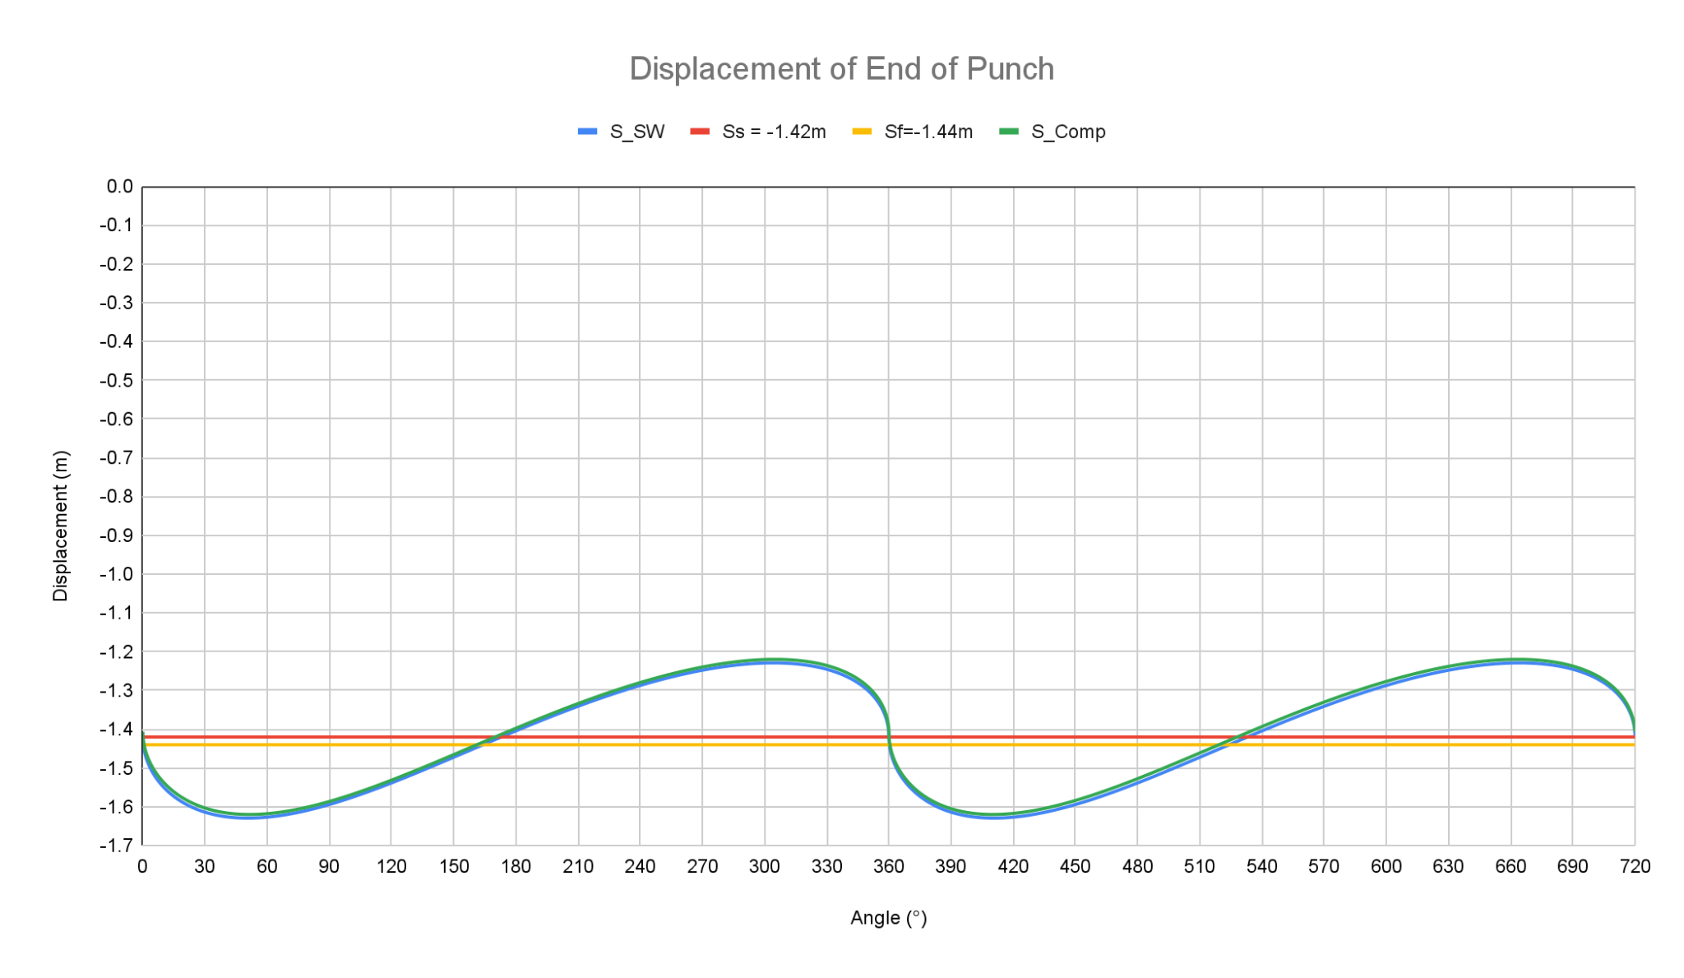

**Figure 7:** Velocity Results Comparing Computational and Simulation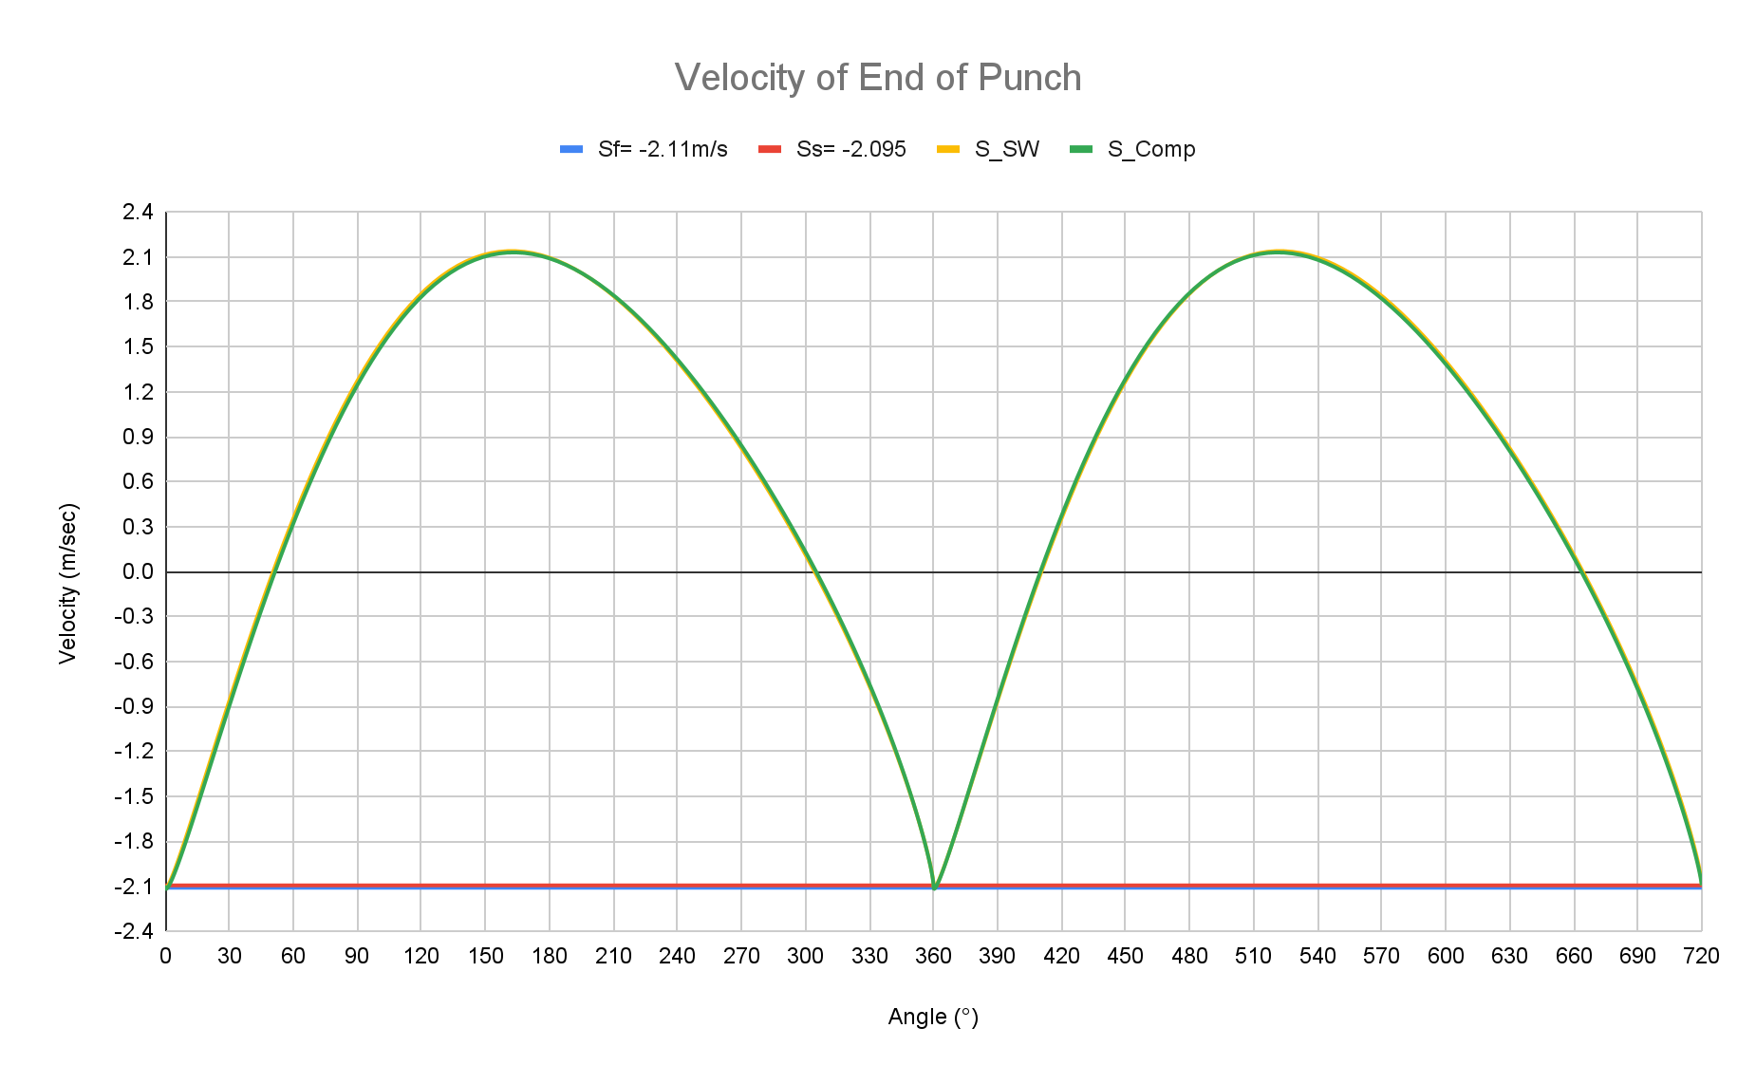

**Figure 8:** Acceleration Results Comparing Computational and Simulation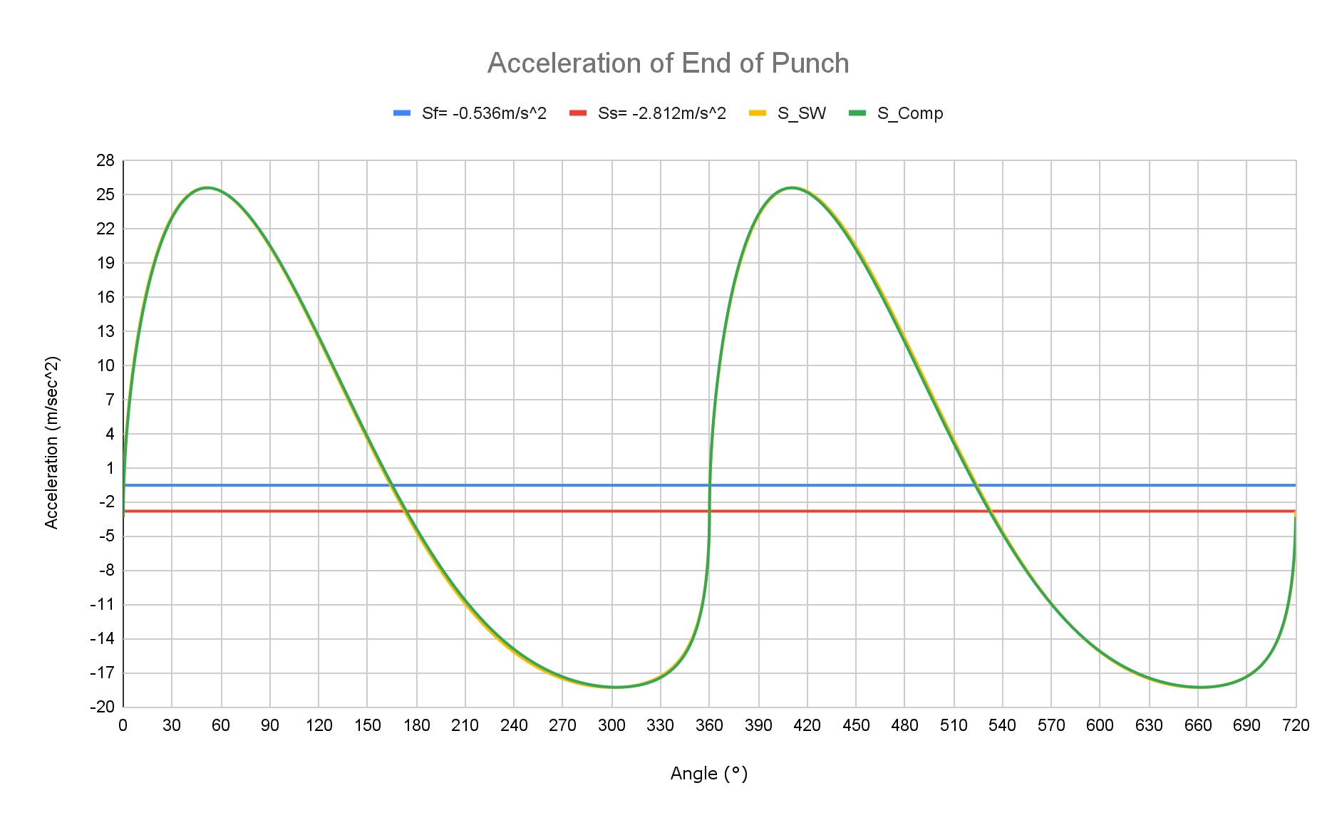

# Graphical Results

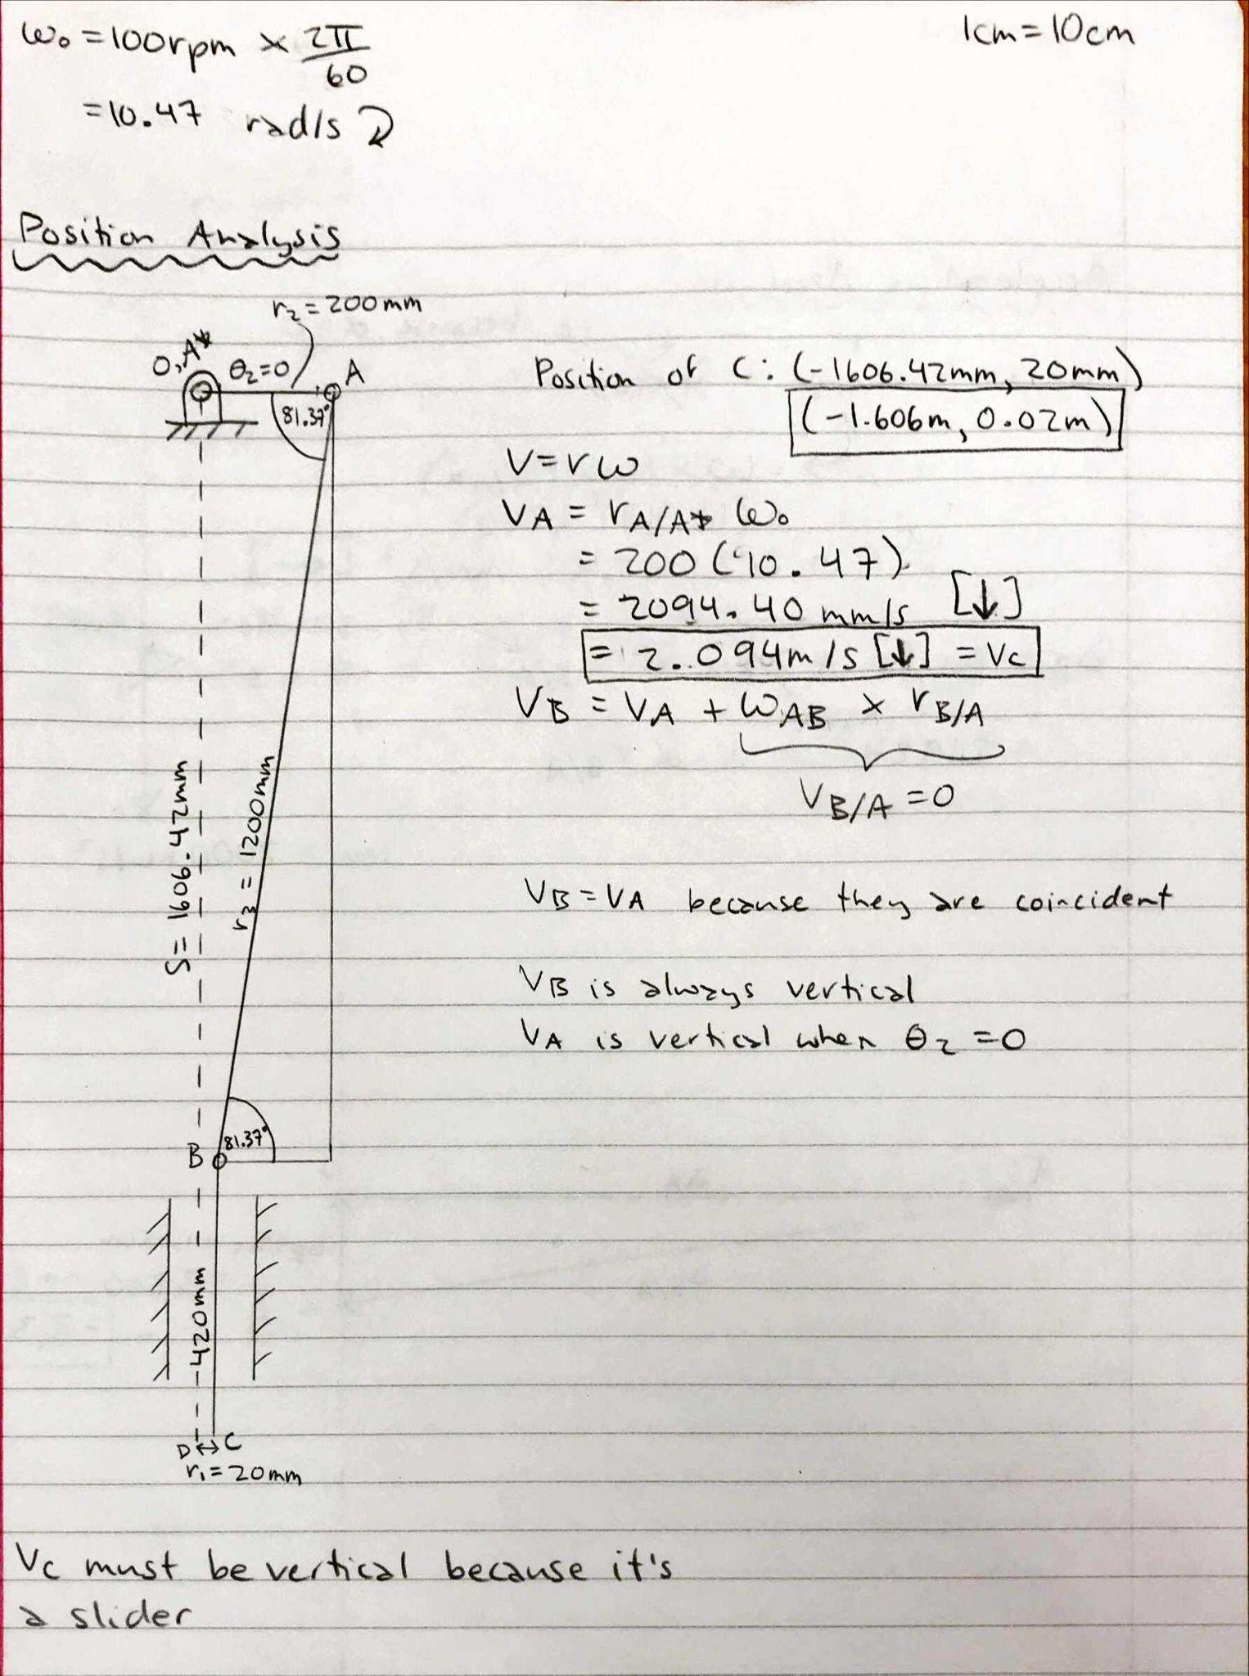

**Figure 9:** Graphical Results for Position, Includes Calculation for Velocity Polygon

**Figure 10:** Graphical Results for Velocity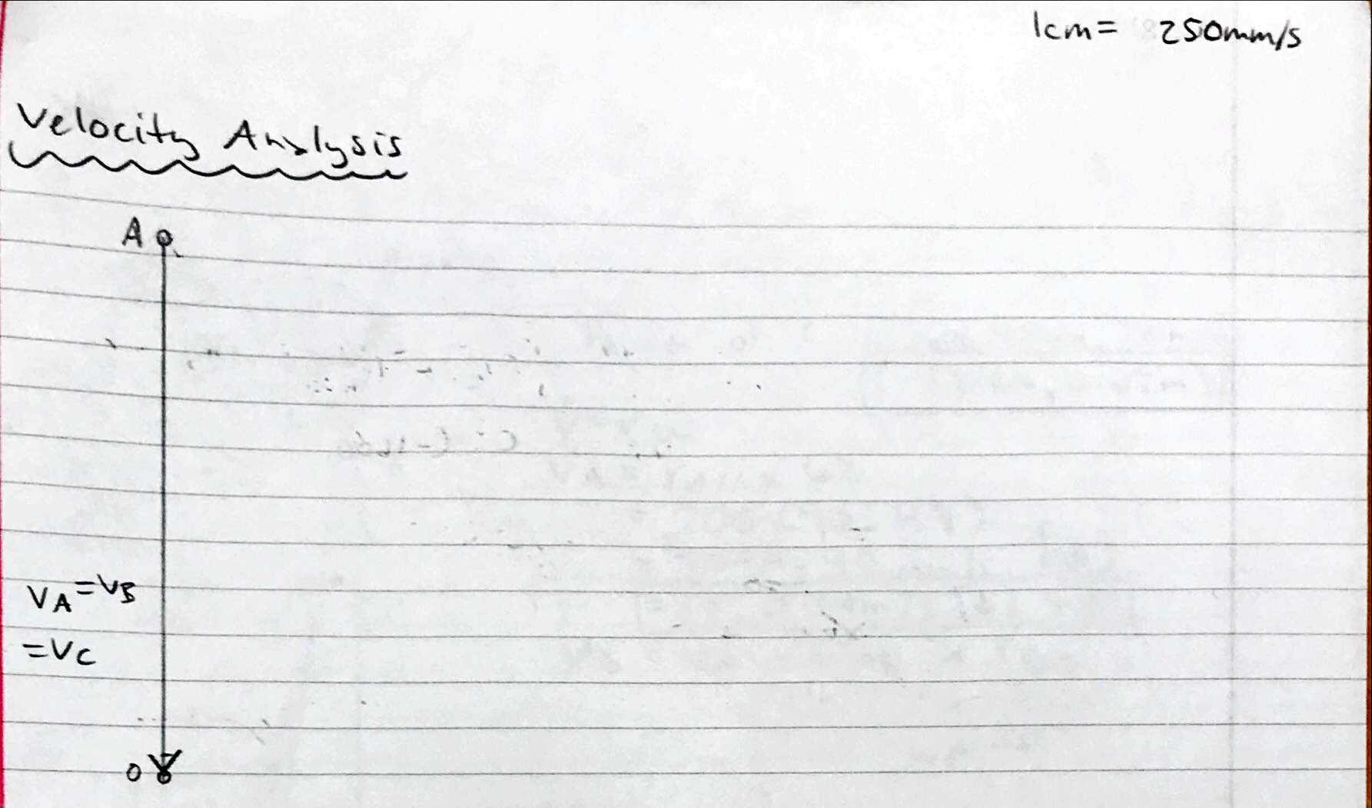

# 

# Figure 11: Graphical Results for Acceleration, Includes Calculation for Acceleration Polygon

# Discussion

The final design meets the original design because the analysis results were within the range given to us in the design requirements. When the values were chosen, the requirements were followed and thus the end values were within the range.

Ss values from the SolidWorks simulations are very close to the values obtained in our graphical results, and therefore, are acceptably similar. The small dissimilarities are due to physical measurement errors in our graphical results. The measurement errors are more significant in our acceleration analysis because they stack when progressing from position to velocity to acceleration analysis.

Our computational analysis yields small errors for position, velocity, and acceleration. Part of this error was in setting the crank angle in Solidworks to be exactly 0° when time is zero. The error in the position analysis was also a constant error which would be due to not having the distance from the center of the stock to the top of the stroke be exactly 210 millimeters. The error in the velocity and the acceleration charts would be due to Matlab and Solidworks computational engines being run with different accuracy in the amount of significant figures.

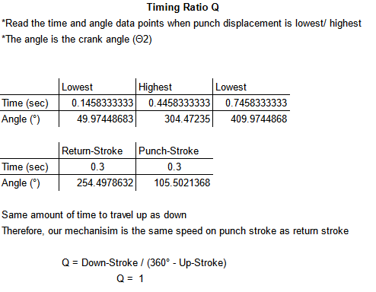

**Table 1:** Timing Ratio Calculations

A timing ratio of 1 indicates the punch travels the same speed on punch stroke as return stroke as mentioned in Table 1. Even though the angular distance traveled is larger for the crank on the return stroke, the distance traveled for the punch is the same and both are done in the same time as each other and as the punch stroke. This is due to the chosen value of eccentricity; this is a result of our choice and not one of our objectives, although it can be seen that this would allow for easier timing of other processes in a factory or if the punched material was moved by hand.

The velocity of the punch when it first hits the stock, from the graphs of linear velocity, is 2.09 m/s [down]. Since we have over 1 m/s on impact, we meet the requirement. If we didn’t meet the requirement, we would increase our punch speed by either increasing the motor angular speed and/or increasing the length of the crank arm. The first choice would be to increase the angular speed of the motor as increasing the crank arm would require dismantling and reassembling the mechanism. The speed increase is also the primary choice as increasing the length of the crank arm would mean that the timing ratio would change which may not be a desirable outcome.

# 

# Conclusions

Completing this project has emphasized the advantages and disadvantages of the different methods of analysis. Solidworks analysis is medium accuracy and is usually the fastest method when dealing with more complex machines. Graphical analysis is fast to solve, but inaccurate due to measurement errors. Finally, computational analysis is the most accurate, but takes the longest to implement. Solidworks analysis also provides the designer with a 3D model which can then easily be quickly modified and viewed, whereas changing a parameter for graphical or computational requires running through the calculations and drawings again.

# 

# Appendix

